Simple Encryption (FlagYard) – WriteUp
Debonmoy Pal
Name – Simple Encryption
Desc - Just a simple encryption algorithm based on basic arithmetic operations.

Code Analysis
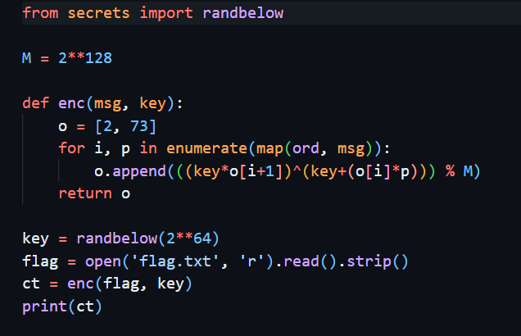
The encryption uses a modulus of 2^128 which means the result of each step is reduced modulo 2^128.
The algorithm starts with 2 known values 2 and 73.
A random key is generated between 0 and (2^64 -1). I don’t know the key, but the size is limited to 64 bits.
The main encryption formula: o.append(((key*o[i+1])^(key+(o[i]*p))) % M)
Here p is the numeric value of a plain text character.
Output Analysis:
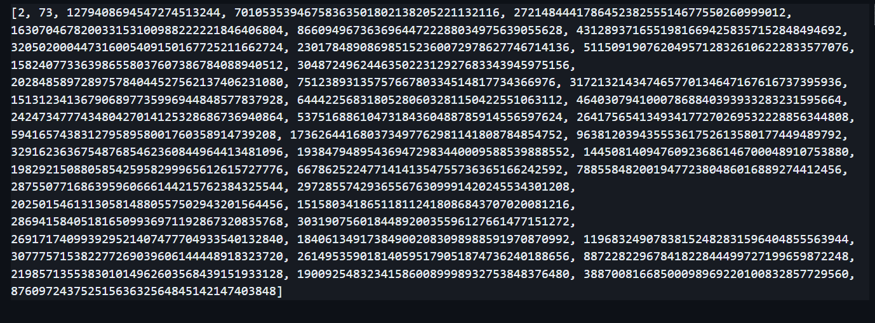
The file contains a list of large integers where the first 2 numbers are not encrypted characters and the remaining numbers are generated during encryption. There are 47 integers in total where 45 are encrypted characters. I now need to reverse the encryption process.

Vulnerability Identification:
The main weakness is the relationship between consecutive ciphertext values.
Initial values are known to me and I get the subsequent values from the ciphertext.
I also know the key is smaller than 2^64. These clues provide useful mathematical snippets for recovering the key.
Once the key is known, I can test each character against the encryption formula to recover the plaintext.

Key recovery:
From the source code, I know:
M = 2**128
o = [2, 73]
key = randbelow(2**64)
And the first encrypted value:
c2 = ((key * 73) ^ (key + 2 * p0)) % M
I know the value of c2 from output.txt but both key and the 1st plaintext character p0 are unknown.
If there’s a possibility of 64-bit integer key and the first character is a printable ascii then:
Only 95 possible printable ascii characters exists from decimal 32 to 126.
So we use an SMT Solver to recover the key:
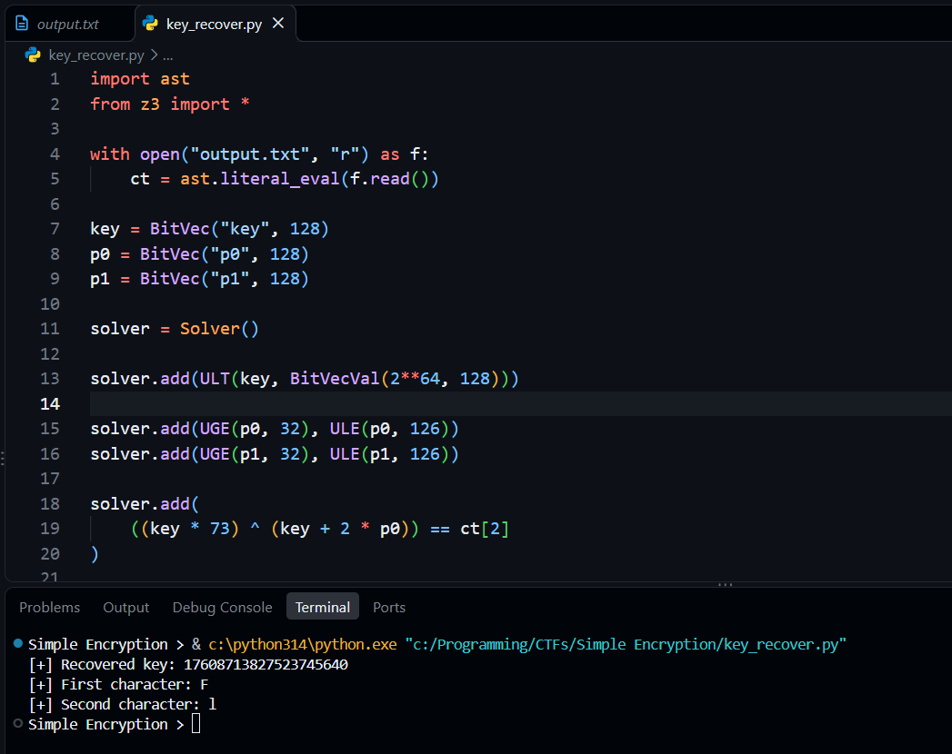
The key recovered is: 17608713827523745640

Flag recovery:
Now to find the flag, for each position, I try printable ascii character and check which one reproduces the corresponding ciphertext value.
The original formula:
((key * previous_value) ^ (key + previous_previous_value * ord(character))) % M
For every candidate character:
- Convert the character to its numeric ASCII value.
- Apply the encryption formula using the previous two values.
- Compare the result with the corresponding ciphertext value.
- Keep the character if the result matches.
And I have to repeat this process for all 45 characters.
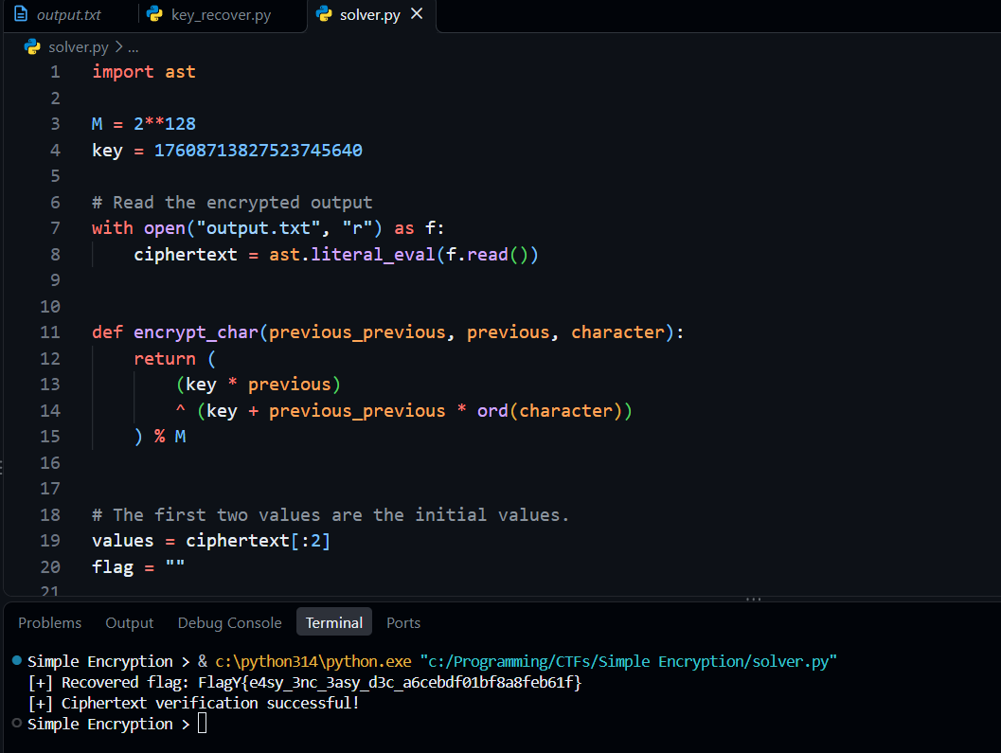
Final Flag: FlagY{e4sy_3nc_3asy_d3c_a6cebdf01bf8a8feb61f}

